- A prayer for those who are finding separation from friends & family hard to bear, by W. David O. Taylor, Asst. Prof. Theology, Fuller Seminary.
O Lord, you who were alone in the wilderness and in the garden
be with me in this time of singleness and solitude;
and when I feel tempted to believe
that I have been abandoned by friends and forsaken by God,
may I sense the sweet presence of your Spirit
and the ministering care of your angels,
nourishing me in my hour of need,
so that I might know that I am never alone
but rather filled and fortified by your very real presence.
In your name.

Some hymns you may enjoy
While we are not meeting for worship, you can enjoy hymns & songs online, for example, on YouTube. You can sing along – nobody can hear you!
- Ride on, ride on in majesty by H.H.Milman (1791-1868)
- Make way, make way by Graham Kendrick (1986)
- All glory, laud, and honour by J.M.Neale (1818-66)
- You are the King of Glory by Mavis Ford (1979)
- My song is love unknown by Samuel Crossman (1624-83)
- Cornerstone by Hillsong Worship (2012)
- I will enter his gates with thanksgiving by Leona von Brethorst (1976)
- Give thanks to the Lord by Chris Tomlin (2001)

Points for Action
- From Monday to Saturday at 8.15am each day, join us for Morning Prayer online. There will also be online worship on Sundays, and throughout Holy Week. Email revdsmday@cantab.net for details of how to join in.
- Take time to read Matthew 26:14-27:66 in one sitting. We usually hear Scripture in small pieces, so to hear the whole Passion story is powerful.
- Remember that the present situation is unprecedented, so your emotions and reactions may be unexpected. They will vary over time, and you may find all this disturbing. Be patient and gentle with yourself and others.
- As spring brings plants back to life, and as council resources are spread thinly, if you are able to, keep the public areas near your house tidy.
Any feedback to Stephen Day. 01954 264226 or revdsmday@cantab.net
4
Palm Sunday – 5th April 2020

Readings: Lectionary Year A, Palm Sunday
Liturgy of the Palms:
Matthew 21:1-11 Jesus arrives at Jerusalem as Messiah, fulfilling prophecy.
Psalm 118:1-2,19-29 An appeal for salvation through God’s steadfast love.
Liturgy of the Passion:
Isaiah 50:4-9a God’s servant, though insulted, is faithful, and not disgraced.
Psalm 31:9-16 A plea to God when in great physical and mental distress.
Philippians 2:5-11 Jesus, after his supreme humility is supremely glorified.
Matthew 26:14-27:66 The full story of Jesus’ final hours.
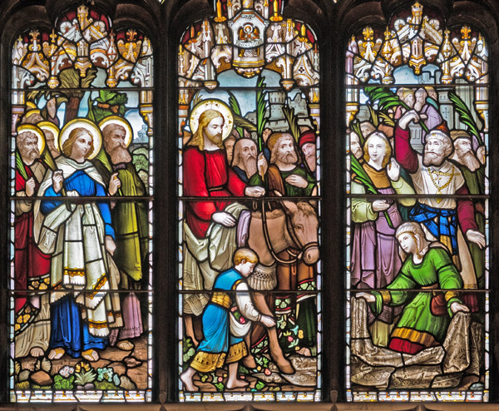
Glass by James Ballantine (1870s) in St. Giles’ Cathedral, Edinburgh.
The expression the artist has given to Jesus is at odds with the ‘party atmosphere’ of the onlookers. How could you imagine yourself in the place of the various characters depicted (including the ones in the background)?
Some thoughts on the readings
- Psalm 118:22 is a reminder that God judges by different criteria from us. We should be wary of rejecting anyone – we are all in God’s image.
- In Matthew 21:9, the crowd are calling out Psalm 118:26. Ordinary Jews, not just the ‘religious specialists’ had a deep familiarity with the Psalms which they could draw on in times of celebration and lamentation. We would do well to recover some of this familiarity for ourselves.
- God’s servant in Isaiah 50 – usually taken as a prophecy of the Messiah – has words to “sustain the weary” (v4). Compare this with Matthew 11:28.
- Paul’s description of the exalted Jesus in Philippians 2:10-11 draws on God’s words in Isaiah 45:22-23, further emphasizing Jesus’ divinity.

Suggestions for further Bible reading
Zechariah 9:9-10 Jesus consciously fulfills this prophecy of peace: when the king arrives he brings an end to violence and even to the means of violence.
Psalm 50:7-15 God has no need of anything, let alone what we humans can provide, yet Jesus is willing to admit need rather than demand by right.
Revelation 19:11-16 Jesus, on a white horse rather than a donkey, leads out an army for the final battle against all the forces of evil. The contrast between this and the humility of the Zechariah reading mirrors the contrast in Philippians 2 between verses 7-8 and verses 9-11.
What other Bible passages come to mind when you read today’s readings?
Remember there are some great online Bible study resources such as thebibleproject.com which has short animated videos about Biblical books and themes, and biblegateway.com for reading the Bible in a wide range of different translations. It also has a search facility for finding what you need.

Points for Prayer
- Give thanks for the neighbourly acts which have been brought out by the covid-19 crisis, and the ways people are connecting with each other.
- Pray for everyone involved in the health services – in hospitals, surgeries, and the community. Pray that they will be equipped with everything they need, and will have stamina, wisdom, compassion, and chances to rest.
- Pray for all students due to take exams next term: that they will be well supported by their learning establishments, and protected from anxiety.
2
- Pray for all that churches will do on this most unusual Easter to bring the message of forgiveness and resurrection to their communities.
Some prayers you may find helpful
- The Church of England has a page of worship and prayer resources at: https://www.churchofengland.org/more/media-centre/church-online
- The Collect (Church of England set prayer) for Palm Sunday
Almighty and everlasting God,
who in your tender love towards the human race
sent your Son our Saviour Jesus Christ
to take upon him our flesh
and to suffer death upon the cross:
grant that we may follow the example of his patience and humility,
and also be made partakers of his resurrection;
through Jesus Christ your Son our Lord,
who is alive and reigns with you,
in the unity of the Holy Spirit,
one God, now and for ever.
- The Additional Collect for Palm Sunday
True and humble king,
hailed by the crowd as Messiah:
grant us the faith to know you and love you,
that we may be found beside you
on the way of the cross,
which is the path of glory.
- A prayer from the Diocese of Bath & Wells:
Loving God,
We pray for all those who are suffering because of the coronavirus,
may they know your healing power.
When we are afraid for ourselves and our loved ones,
give us your strength and courage.
When we feel alone and isolated,
reassure us with a sense of your presence.
Give wisdom to those in authority
and may our community work together for the good of all.
We give thanks for those who care for others
and ask you to bless them in all they do.
We ask this in the name of Jesus, healer and physician.
3

